The Rising Prevalence of Computer-Written Content

How Far We’ve Come, and Where We Are Going

Tristan Searle
For the first time in history, writers may be facing a challenge that has already impacted several other industries: computers stealing jobs. Or, in this case, computer programs. The amount of computer-generated content in newspapers, magazines, professional websites, and online blogs (among others) has never been higher. It may be easier to be a writer than it ever has, with the prominence of self-publishing and social media tools enabling self-promotion, and the demand for writers to produce content to help sustain profitable websites, but it has also never been more threatening. If the algorithmic technology continues to follow its trend of improvement, many professional writers may be out of work within years.
Although robo-writers (i.e., computer programs and algorithms) producing human-like writing seems like a nuance idea, it is not spectacularly new. The Associated Press started using robo-writers in August 2014 to generate thousands of financial reports, while Forbes and The Los Angeles Times have been using them to generate news stories for even longer. Robots have already extruded a number of assembly-line workers, cleaners, and surgical assistants from their positions; The Economist even estimated that half of the jobs in America could be accomplished by robots or computer programs in the next few decades. The benefits to automating processes that would normally require human interaction for business are obvious—after all, robots and computers don’t require salaries, or health insurance, and can get a lot more done in a lot less time.
Computers were predicted to be able to produce award-winning writing in 2014, and five years have since passed without any indication of a computer program being able to write anywhere near Pulitzer-quality work. Jeff Mullin, senior writer at News & Eagle, disagrees with the idea that computer-written content will ever reach human heights; “Can a computer describe the beauty of a sunset, impart the pain of loss, capture the sound of a baby’s laugh, tell the story of lives shattered by a tornado, detail the joy of a soldier reunited with his family, suss out when there is more to the story than officials are letting on.” Robo-writers may be able to replicate mediocre standards of journalistic writing, but it is doubtful they will ever obtain the heights of the greatest writing mankind, much less surpass it.
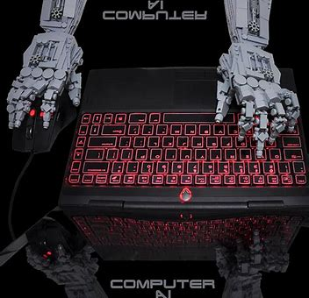
Creative writing in particular seems like a field that will forever be dominated by mankind. One might be confused as to how a computer program could ever replicate human writing in the first place. The answer is human interaction. There is an overall trend in computer-writing algorithms to require human interaction, however limited that interaction might be. As long as this is the case, the capable assistance of computer-writers might be pan out to be a good thing for not only creative writers but professional writers as well. Instead of toiling their days away tapping out one or two pieces at a time, professional writers would have the ability to produce hundreds of reports, manuals, etc., in the space of a single work week just by typing in important facts and word-choices for the writing algorithm to process. Using their insight into writing that other professionals (namely, programmers) lack, professional writers could likely keep their jobs and even be able to increase their value to their employers.
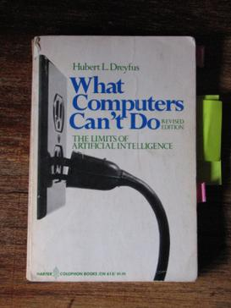
On the flipside, however, there are already books on the market that have been produced by algorithms. Indeed, there are many conflicting reports over the current standard of computer-written content. The ingenuity of writing technology isn’t limited to technical topics; researchers have been able to create a program that can write fairy-tales, quite similar in style to those produced by the Brothers Grimm. It is worth noting that although the stories produced are somewhat smooth, a team has to go in and make them more readable, otherwise they would be considered low-quality. For now, at least, humans are needed for these processes to go well. Although if programmers continue to improve their craft, while creative writers pretty much stay the same as they always have, the publishing industry won’t be safe from computer influence forever.

In the end, there is no real way to tell exactly how computer-written content will affect the future. Shelley Podolny, a director of a company called H5 and a writer on electronic information issues, has this to say on the matter: “With technology, the next evolutionary step always seems logical. That’s the danger. As it seduces us again and again, we relinquish a little part of ourselves.” By sacrificing the human aspect of writing, people sacrifice the thing that makes writing special and worthwhile in the first place. Only time can tell where this slippery slope will lead.

Author Bio:
Tristan Searle is an English student at Brigham Young University – Idaho.

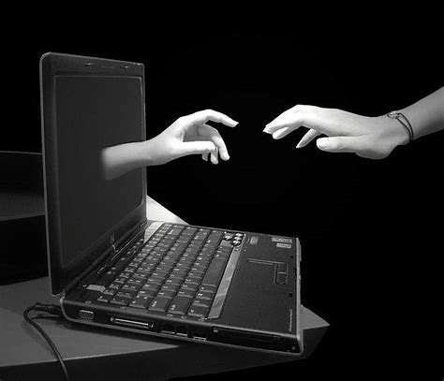
https://www.choosehelp.com/blogs/non-substance-addictions/yale-university-researchers-say-1-in-25-american-teens-struggle-with-2018problematic-internet-usage2019.html

